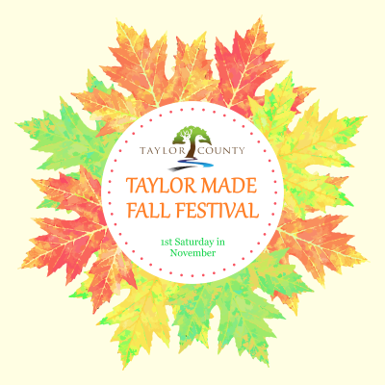
Year 2021 – 3rd Annual Festival – Sponsorship Form
Name: _____________________________________________________________________
Contact: _________________________ Email: ___________________________________
Mailing Address: _____________________________________________________________
Phone Number: _______________________ Cell: _________________________________
Send Logo and form to Shonda Blair at tcdev@pstel.net by August 31, 2021. **______** PLEASE CHECK TO REQUEST INFORMATIONAL BOOTH
Sponsorship funds can be sent through Paypal.com to tcdev@pstel.net
SPONSOR LEVEL – PLEASE CHOOSE YOUR SELECTED LEVEL  Deadline is August 31, 2021  Check and form – Attn: Taylor Made Fall Festival  C/O: Taylor County Chamber of Commerce  P.O. Box 443, Butler, GA 31006 | *______*  The Great Pumpkin Sponsor  $ 1,000.00+ | *______*  Pumpkin Spice Sponsor  $ 750.00 | *______*  Harvest Sponsor  $ 500.00 | *______*  Seed Sower Sponsor  $ 250.00 | *______*  Small Town Sponsor $ amount you can give
Free Booth Spot, help give back to the community, help offer free entertainment, advertised on social media, newspaper, announced at event, and help offer free activities for the children | X
Free Booth spot, help offer free entertainment, advertised on social media, newspaper, announced at event, and help offer free activities for the children |  | X
Free Booth Spot, advertised on social media, newspaper, announced at event, and help offer free activities for the children |  |  | X
Free Booth spot and donation will help offer free activities for the children |  |  |  | X
Individuals that want to give a little something to help make a difference |  |  |  |  | X
Thank You Much for Your Generous Support!

